**FLUTTER PROJECT   
DAILY HUNT -TIMES OF INDIA**

STEP 1: PAGE CREATION

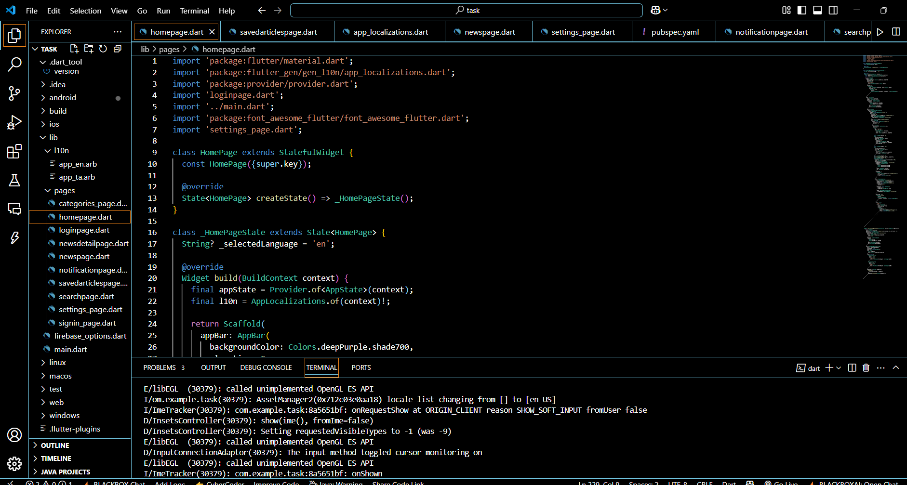

STEP 2: API KEY CREATION

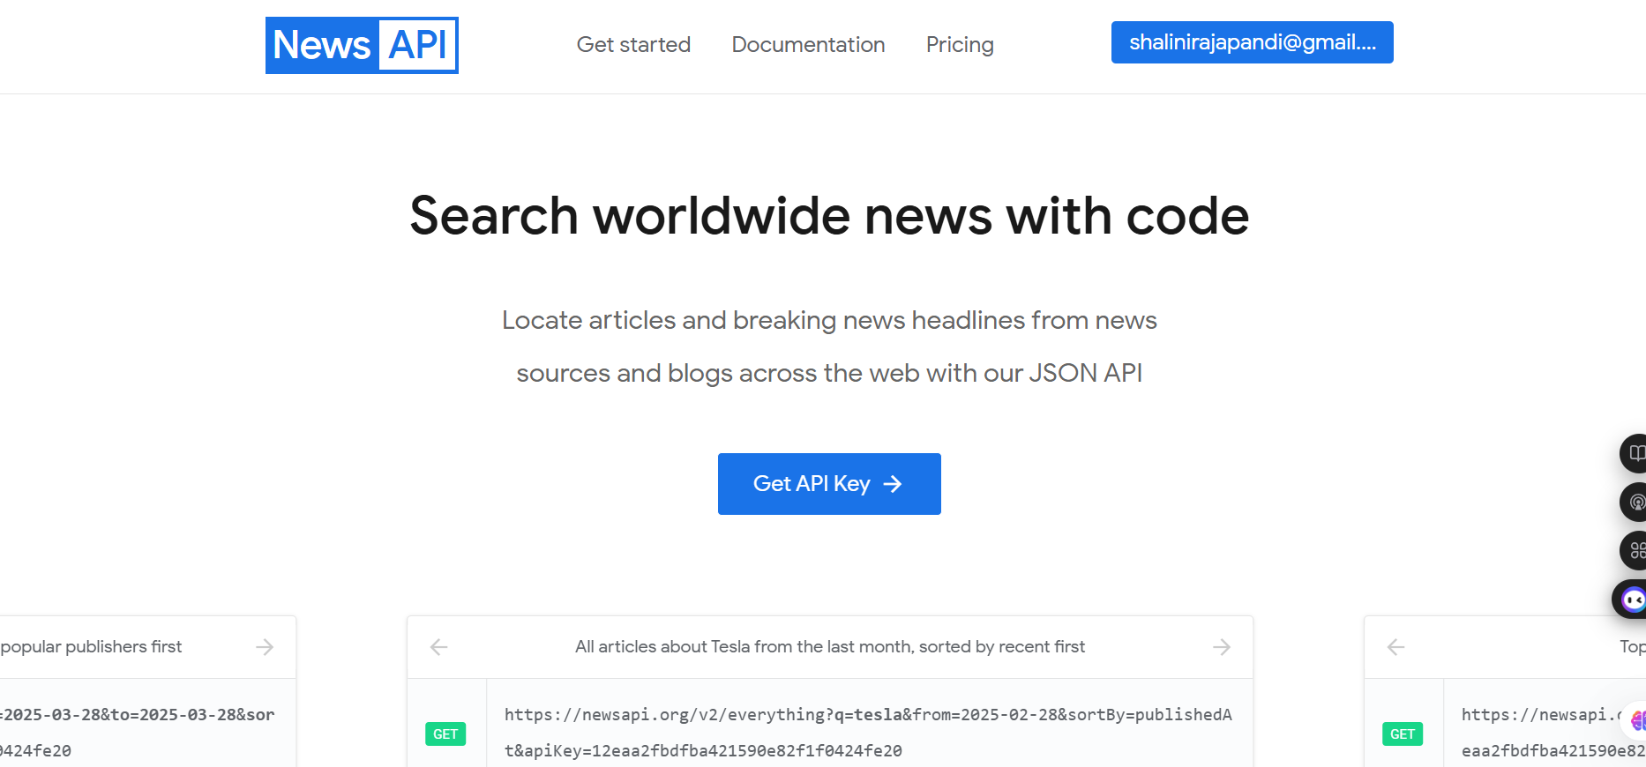

STEP 3: LOCALIZATION

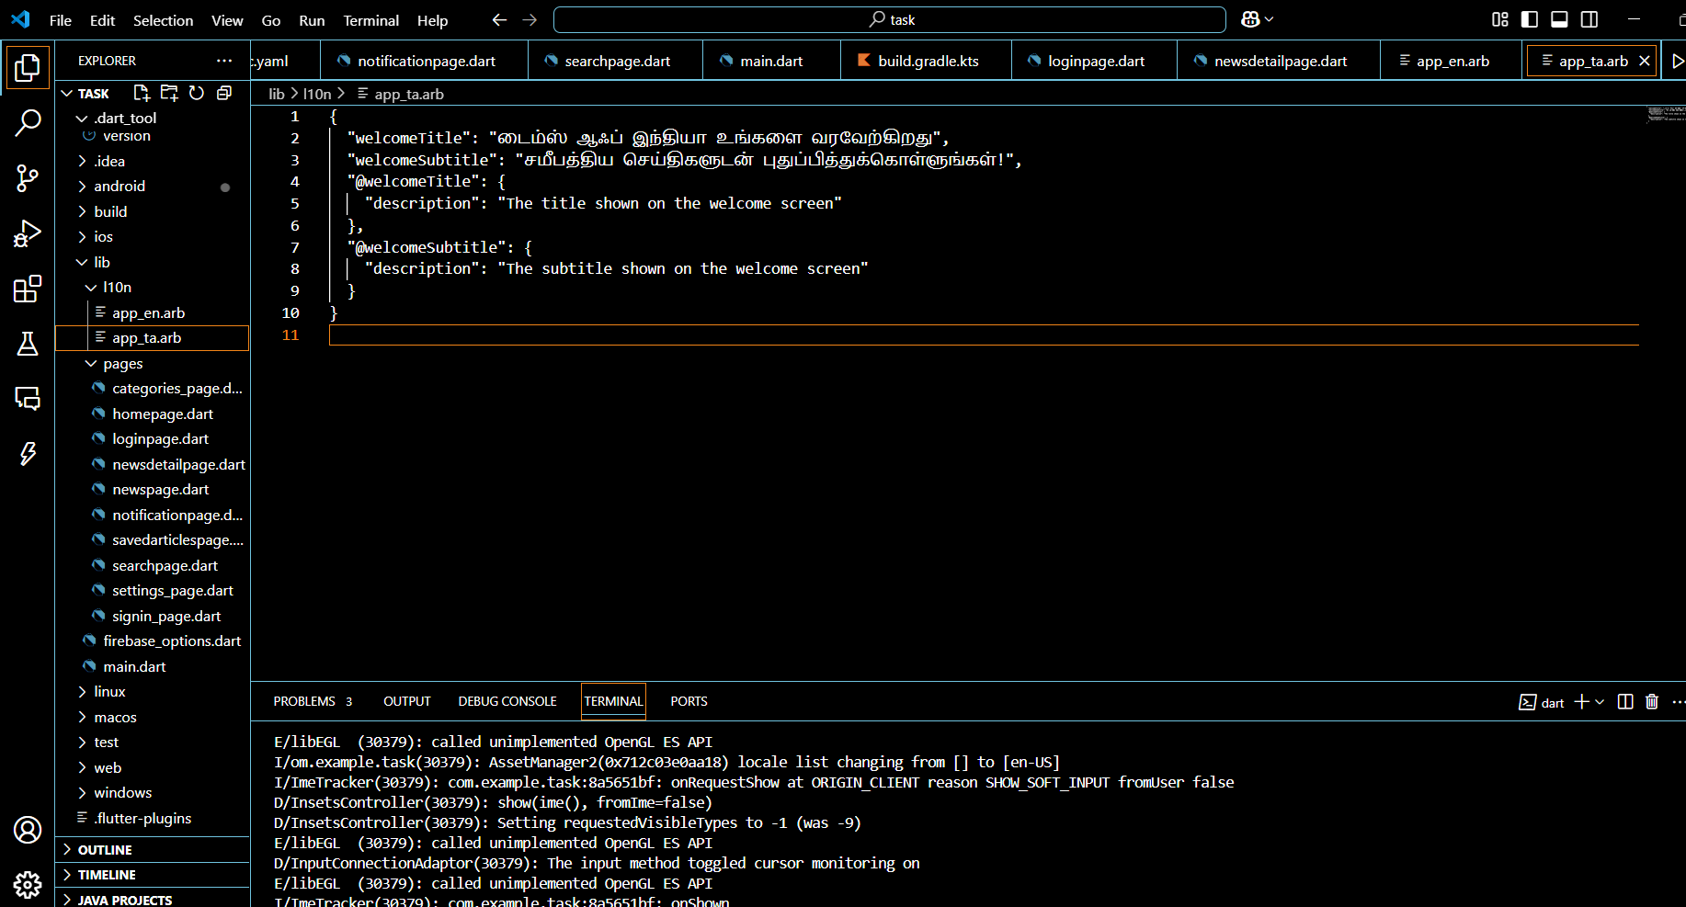

STEP 4: FIREBASE DATABASE

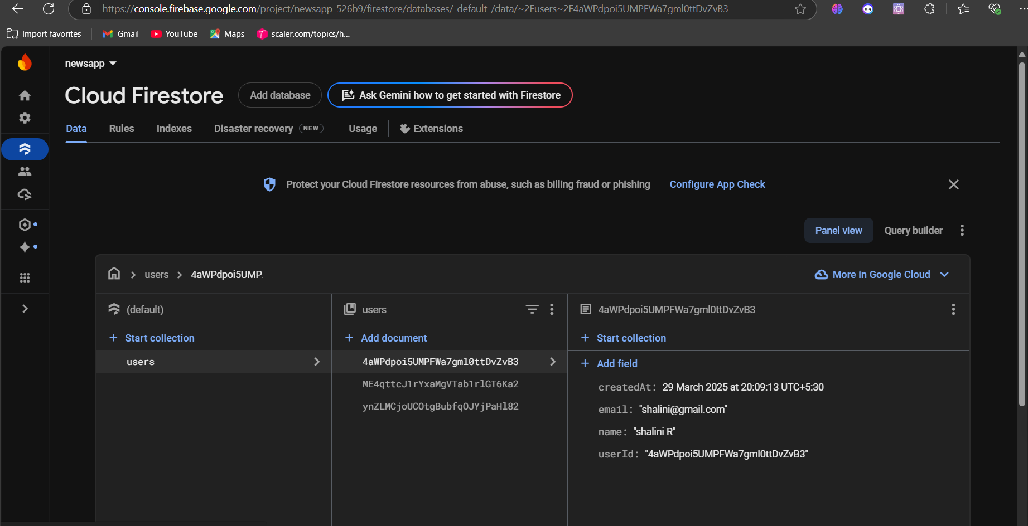

STEP 5: FIREBASE AUTHENTICATION

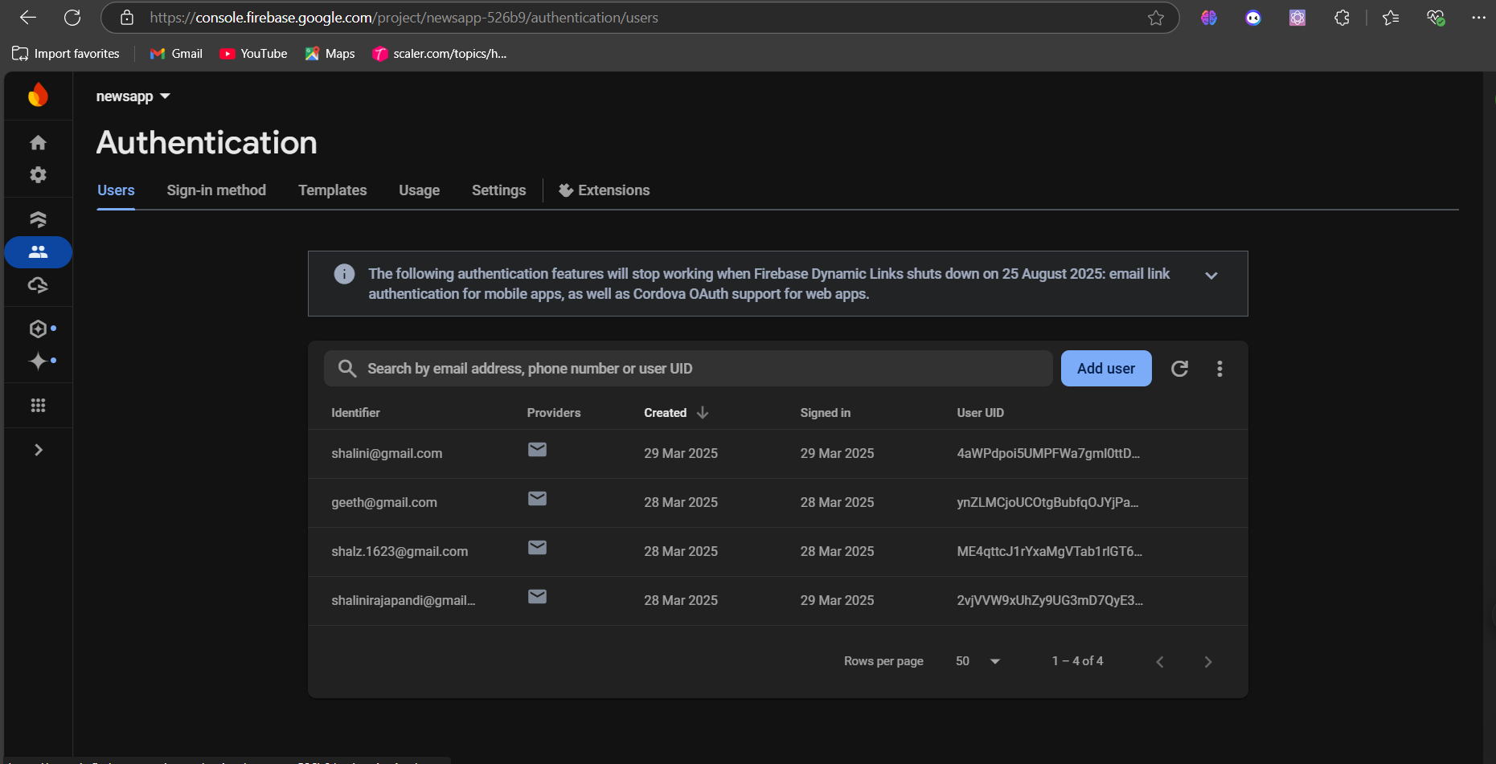

STEP 6: DEPENDENCIES

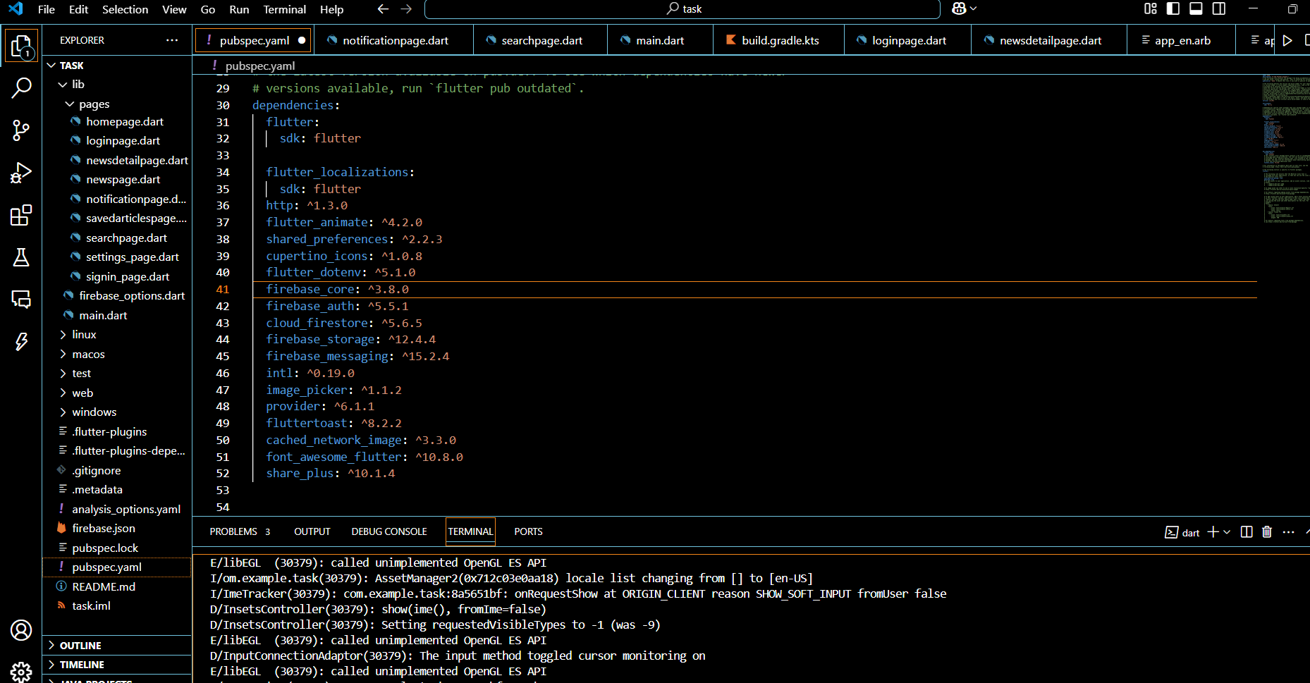

**OUTPUT:**

**HOME**

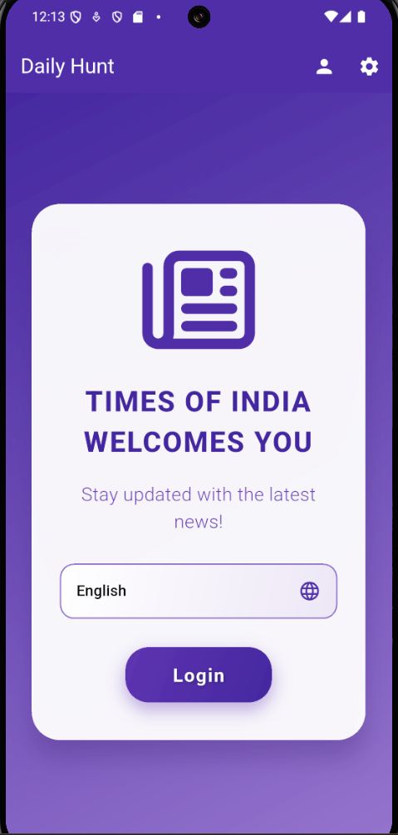

**LOGIN**

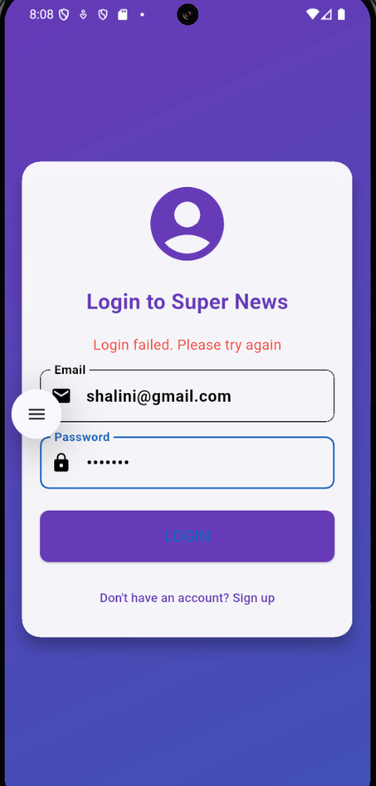

* When we don’t have an account 🡪 sign up
* The user details sent to the firebase database and it added to the authenticated users.

**SIGN IN**

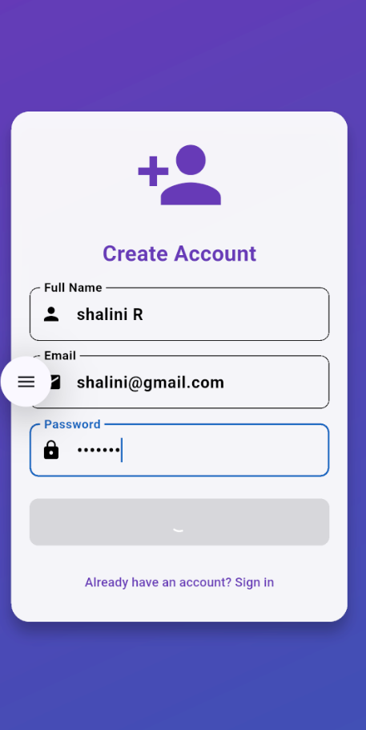

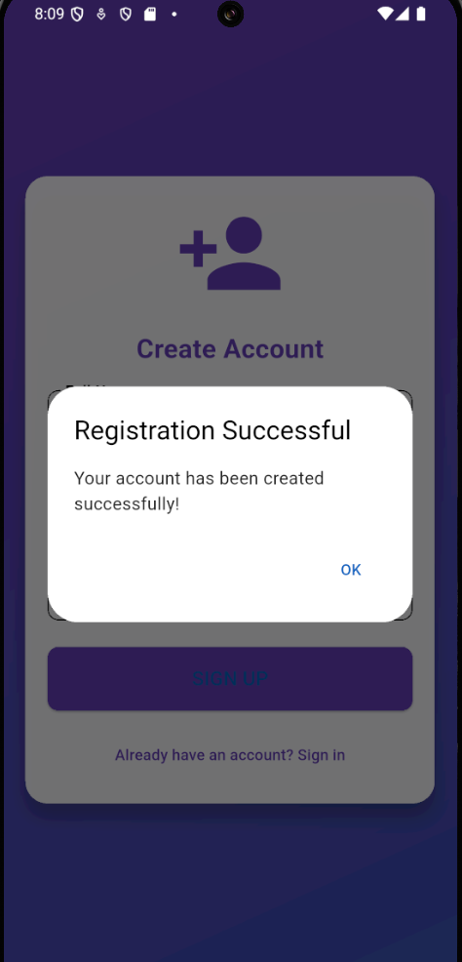

* It navigates to login page 🡪Now user can user the app.

**LOGIN - SIGN IN**

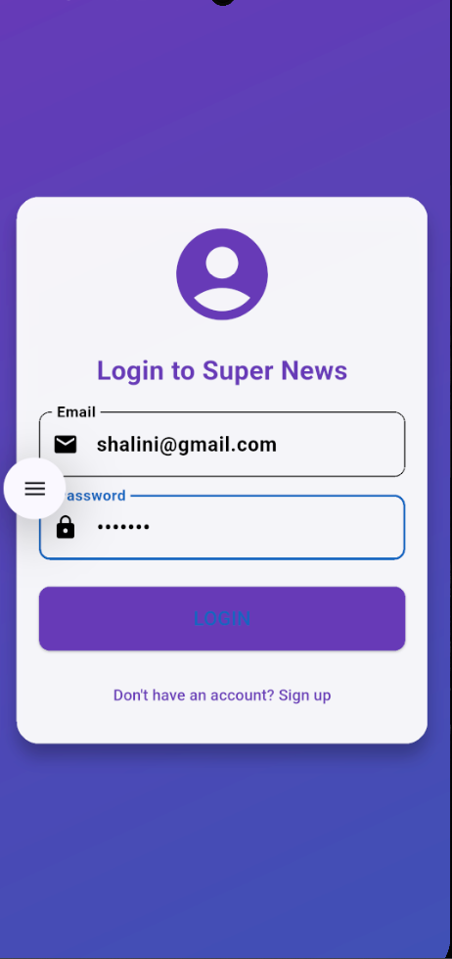

**BREAKING BOUNDARIES**

**CATEGORIES: GENERAL**

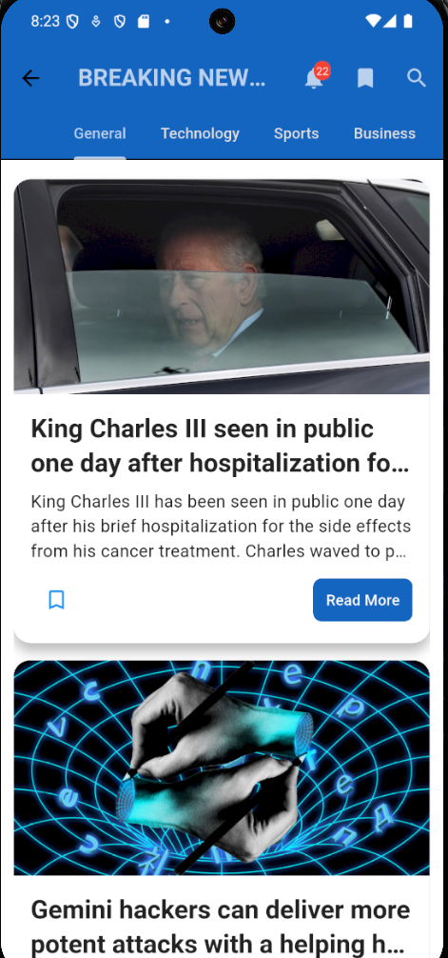

**TECHNOLOGY**

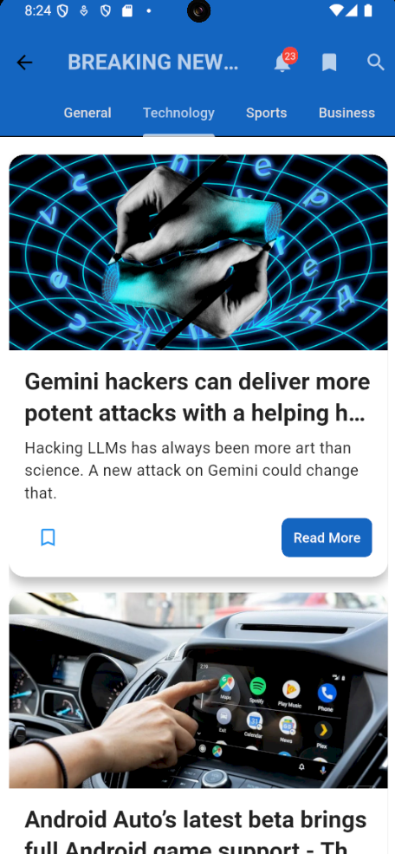

**SPORTS**

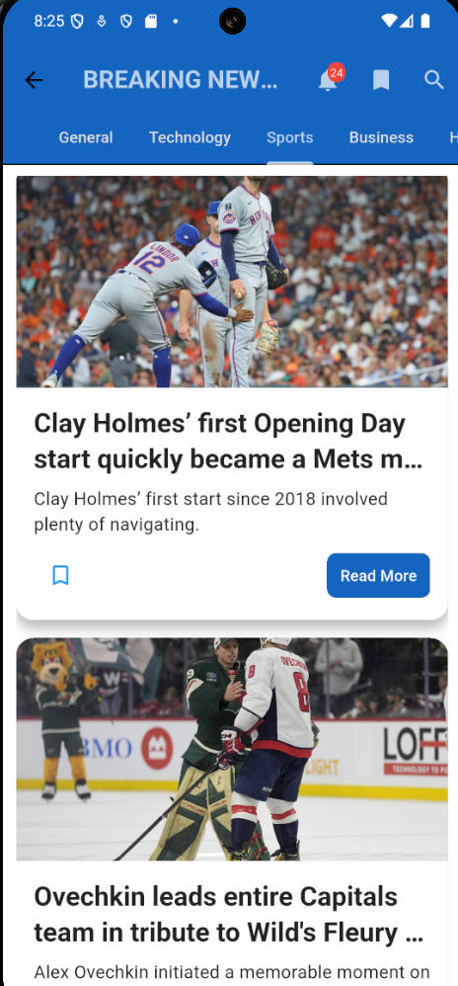

**BUSINESS**

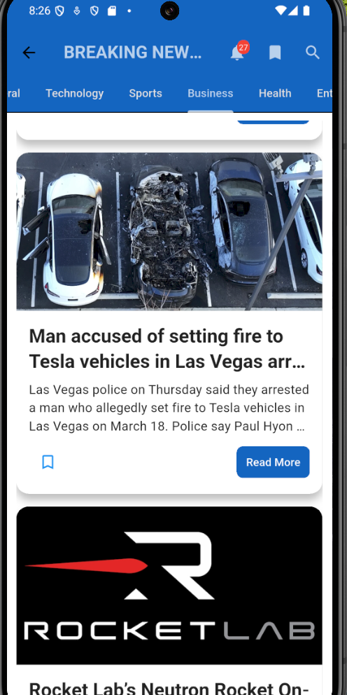

**HEALTH**

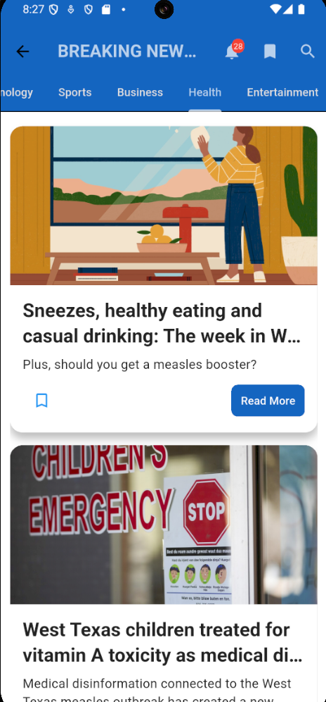

**ENTERTAINMENT**

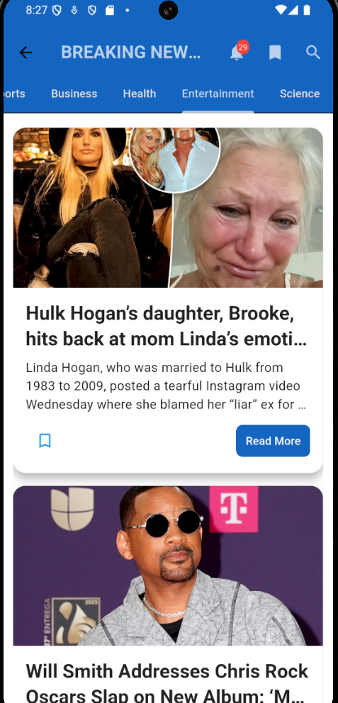

**SCIENCE**

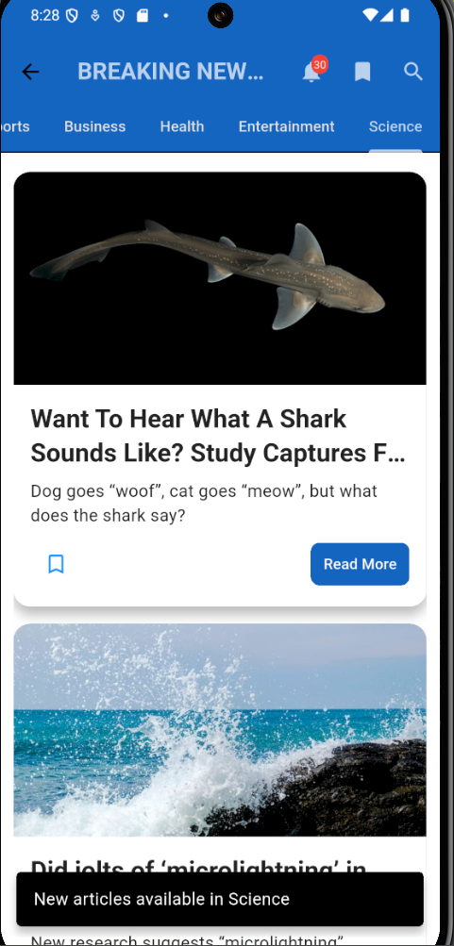

* When we click on Read More 🡪 NEWS DETAIL PAGE.

**NEWS DETAIL**

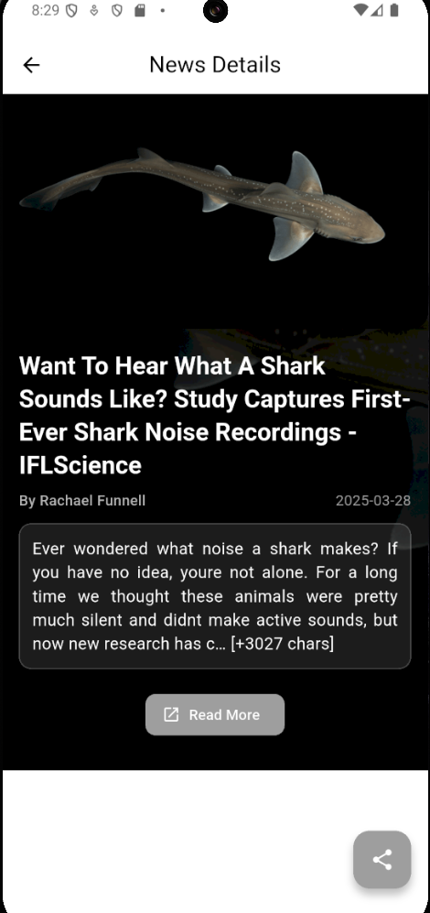

* When we click on Share button 🡪 The URL will be copied and we can share to our friends.

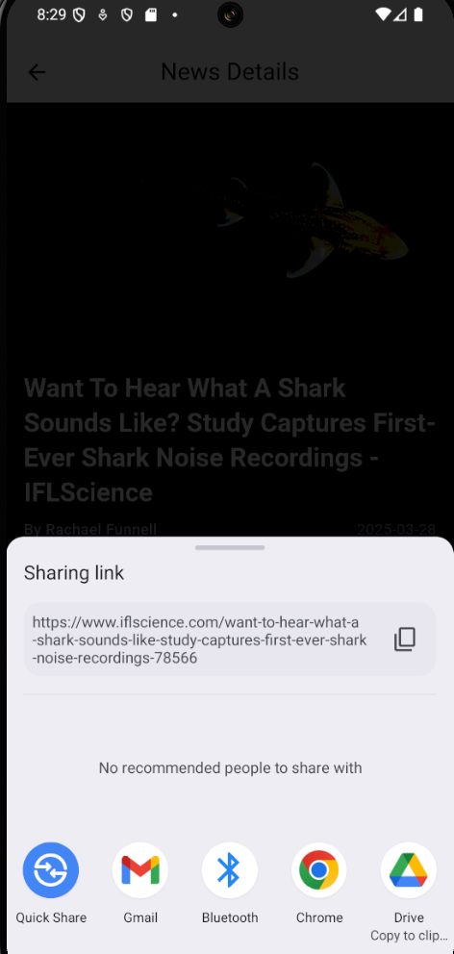

**NOTIFICATIONS**

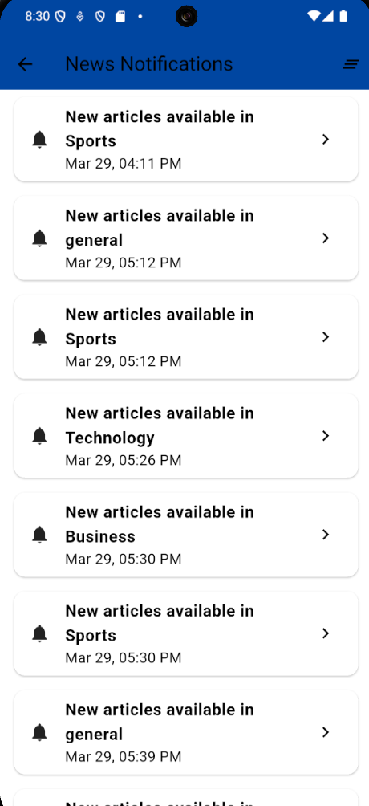

* We can also clear the notifications by clear button.

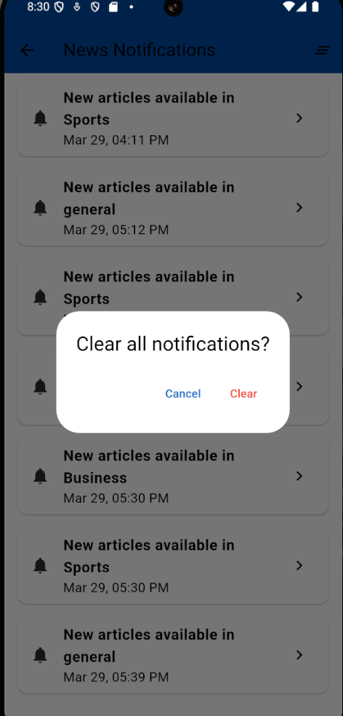

**SAVED ARTICLES**

* When we click on the save icon in news page 🡪saved into the saved page and also, we can delete them by clicking the delete icon.

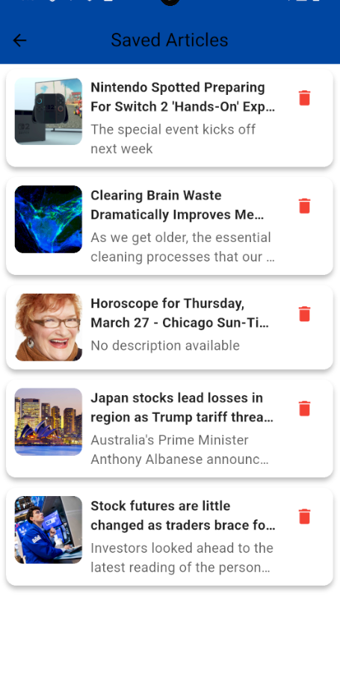

**SEARCH BAR**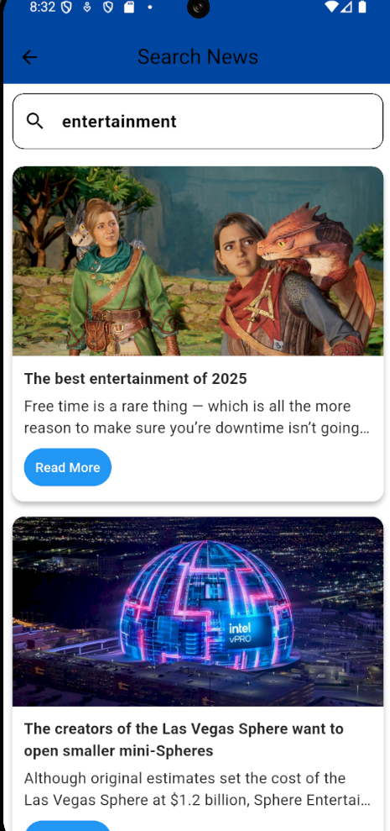

* Read more navigates to the news detail page where we can read the entire detail of the news.

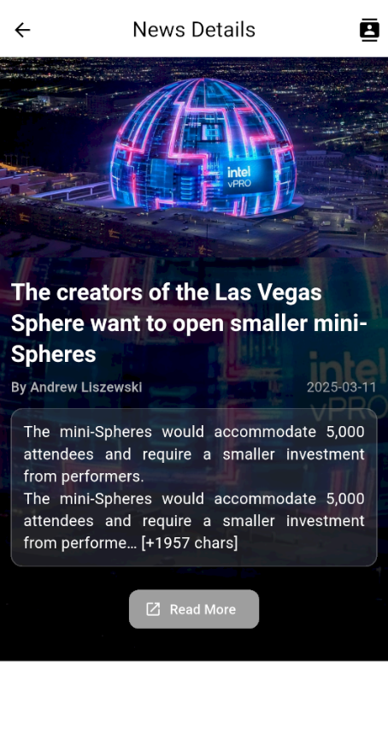

**SHARING VIA CONTACTS**

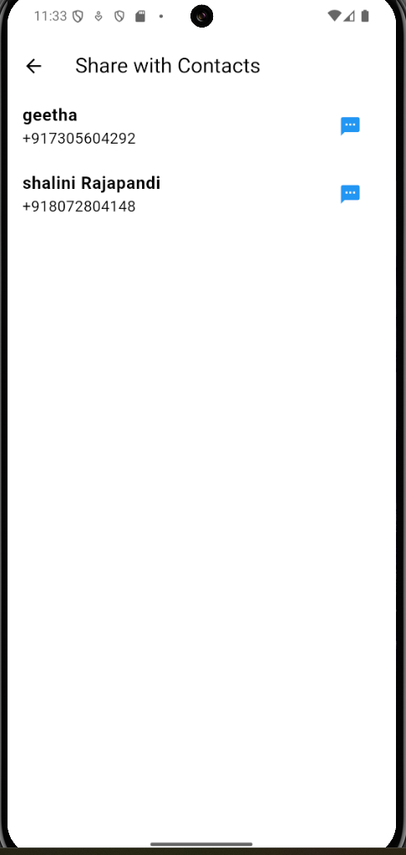

* After fetching contacts, we can share them the link (url) by sms.
* User can open the link and view the website.

**SENDING SMS**

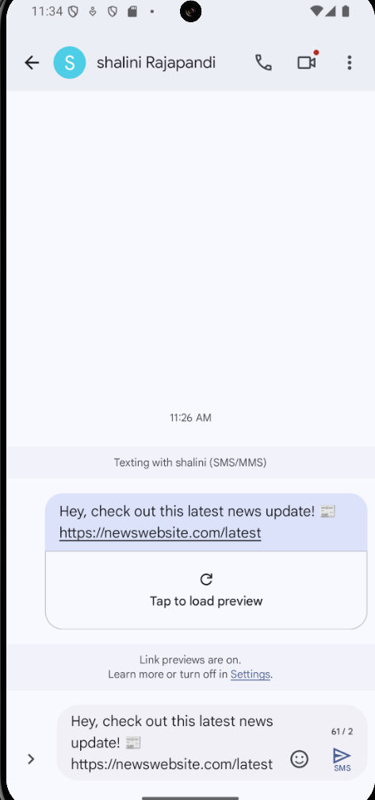

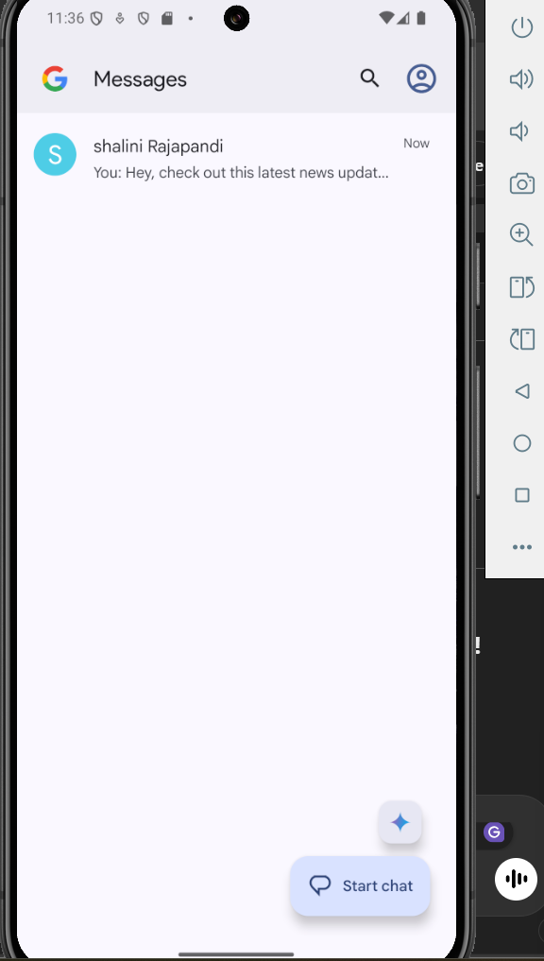

**LOCALIZATION**

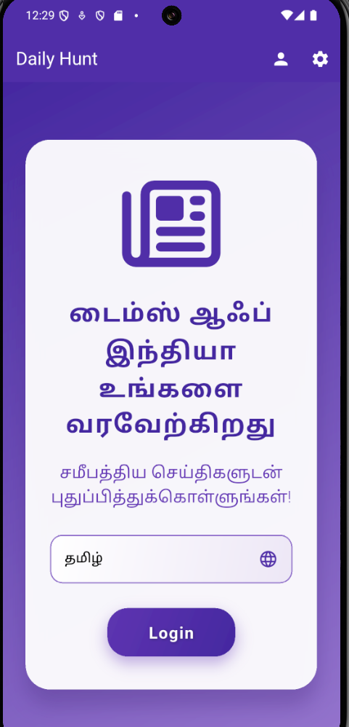

* We can choose the language according to our interest (Tamil or English) using localization.

**SETTINGS**

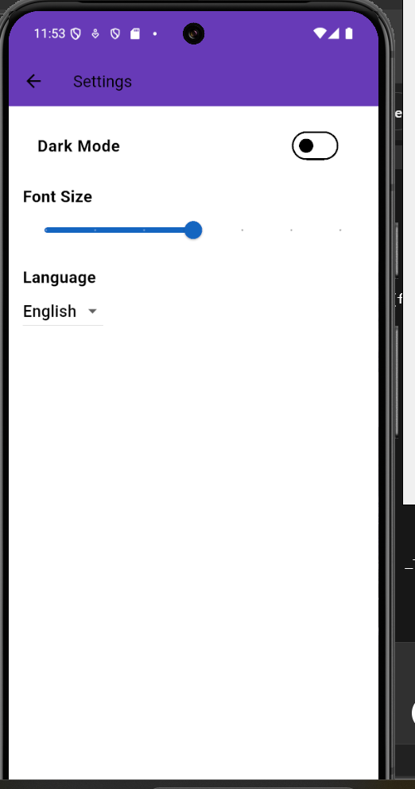

* When I clink dark mode 🡪 it changes to dark mode.
* We can also change the font size and language according to our interest.

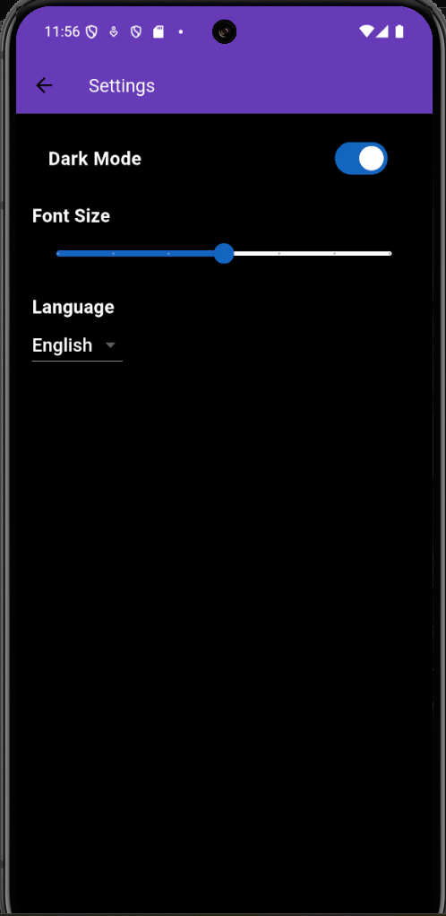

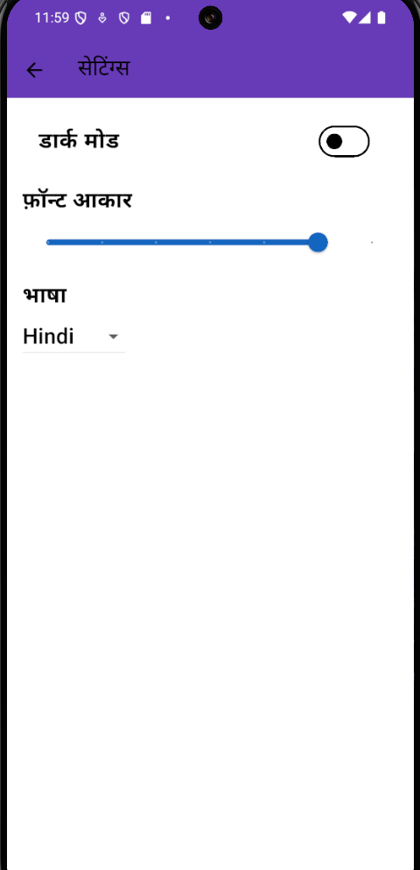

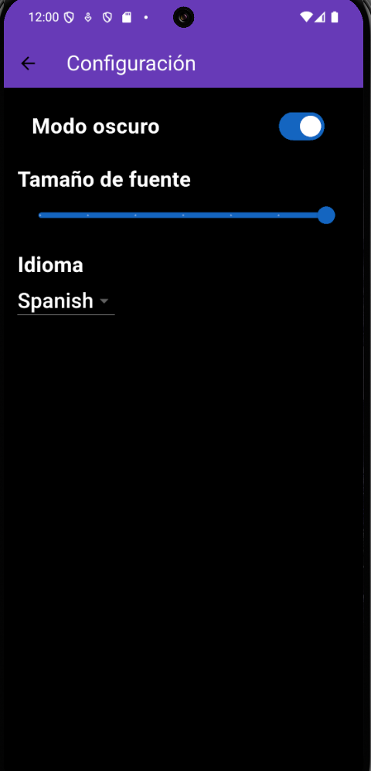

**PROFILE**

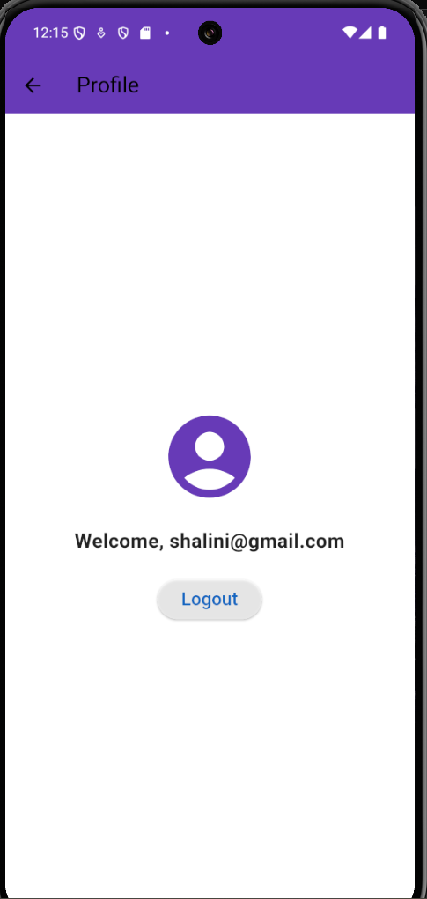

**CONCLUSION**

* The News App is a Flutter-based mobile application that delivers real-time news updates from various sources. It features Firebase Authentication for user login and signup, with persistent login using Shared Preferences and a logout functionality. The app fetches and displays news articles from a public API, showing headlines, images, and descriptions, with categorized sections like Sports, Technology, and Business etc.
* The app has a user-friendly UI/UX, including a Home Page for trending news, a News Detail Page for full articles, and a Profile Page for user settings and logout. It supports localization with English and Tamil, storing language preferences using Shared Preferences. The app also includes light and dark mode support using Theme data.